To discuss how important merging is, please remember the following IMP points.

* Please remember, the code in the master branch is production ready to go code and never mess the files until approve.
* Whatever the development and testing will all be done in their respected branches and it is successful and approved you can merge those branches on master.

Now as of once you are in master branch, you can’t able to see the files that are added with development branch.

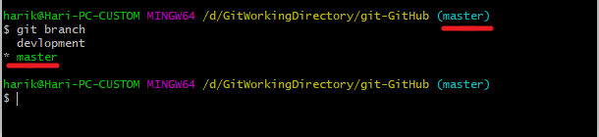

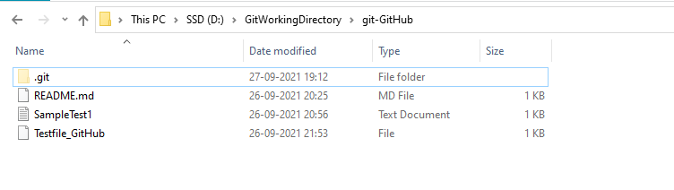

Same now switch development branch and observe it.

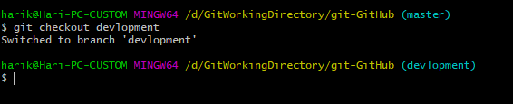

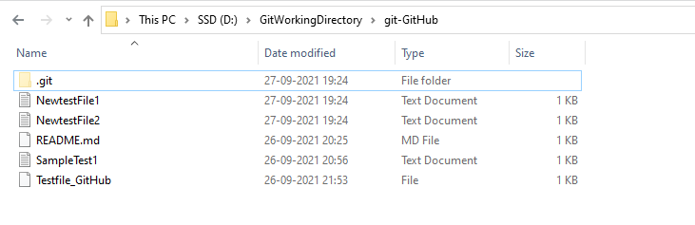

Now all my changes had been on my local repository, if we want to push the code to centralized repository we need to initialize git push command

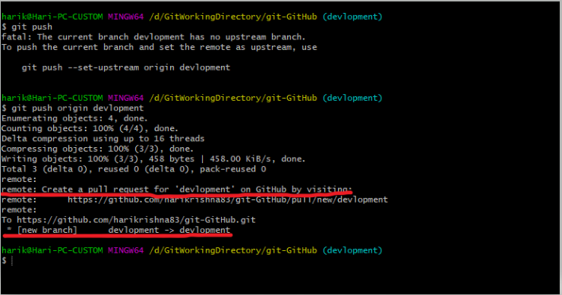

Login to github.com and see whether the new branch got available or not.

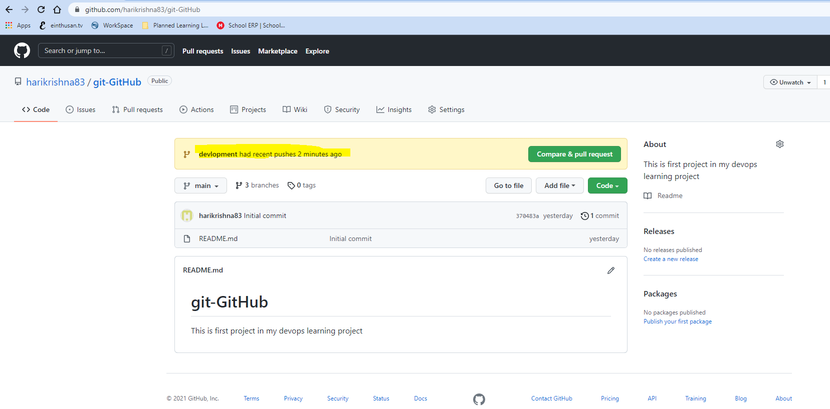

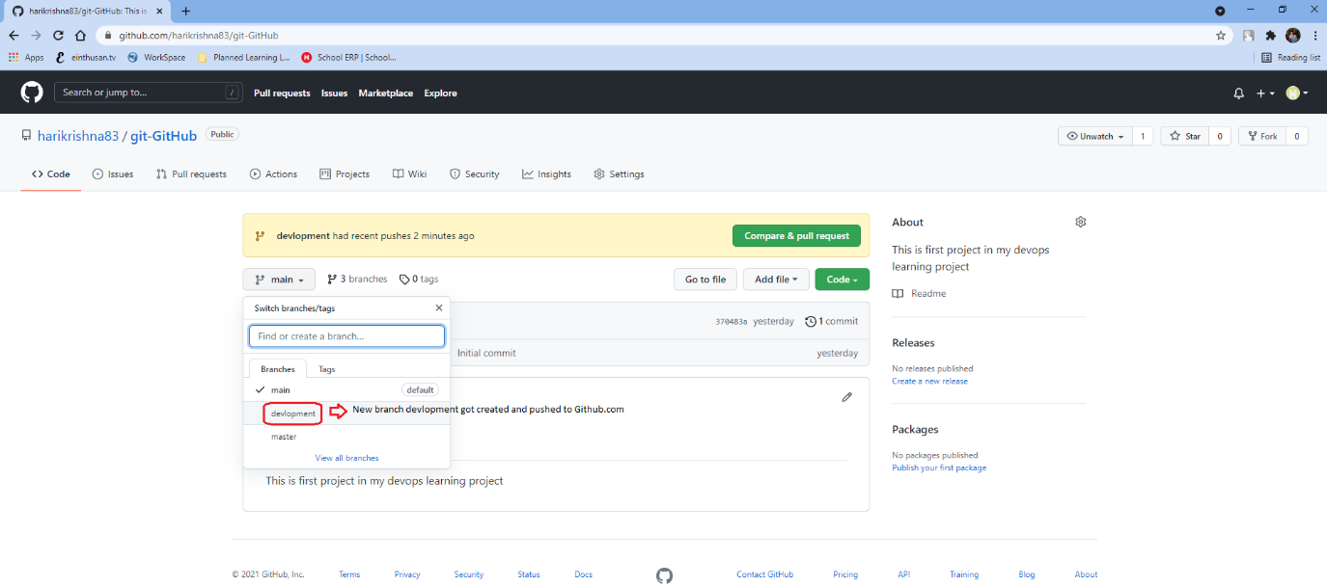

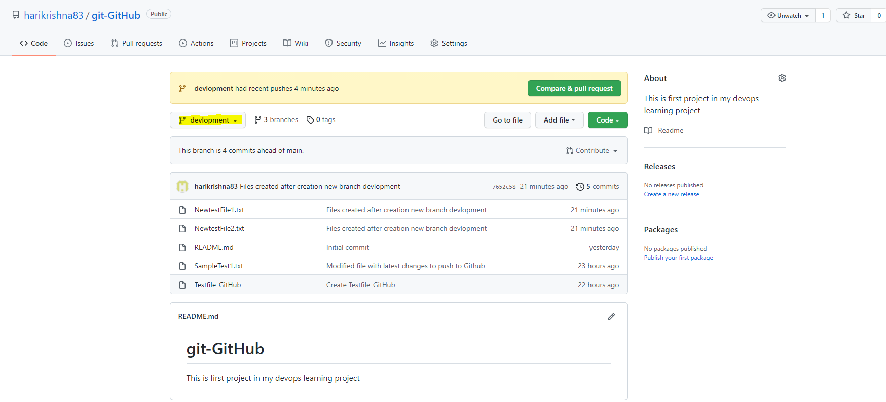

Now I tested the code on development branch and it is completely working fine and I need to merge this code to the master branch

In order to merge, first you need to checkout to the branch that you are merging.

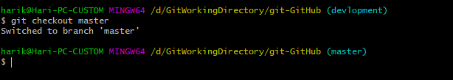

Now once you switched the respective branch issue the command

# git merge <the branch that you need to merge>

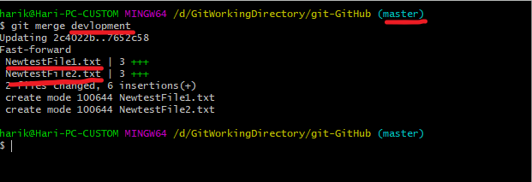

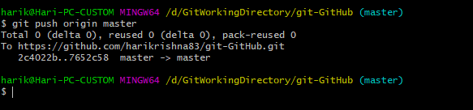

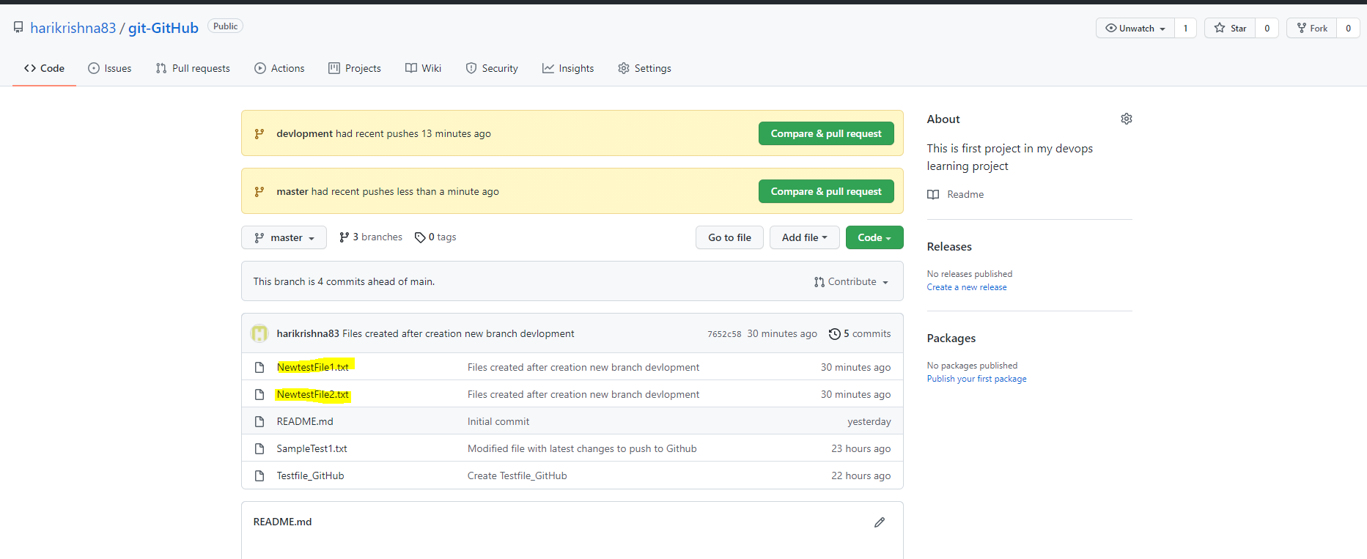

Now I am creating a new branch, and see what are all the files are available on master branch to the new created branch or not.

